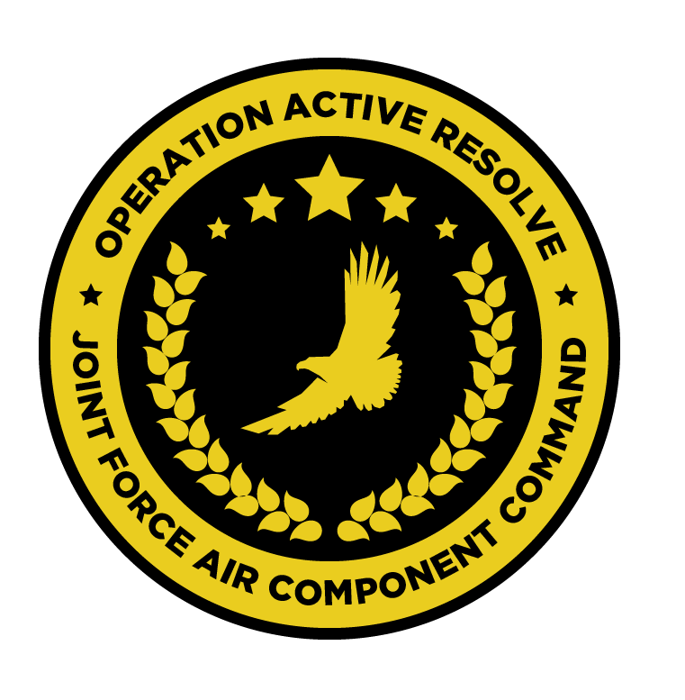

JFACC JOINT AIR OPERATIONS PLAN

OPERATION ACTIVE RESOLVE

# Situation.

## Adversary Forces.

## Friendly Forces.

# Mission.

# Air Operations

## Joint force air organization.

## Joint force air objectives.

## Beddown overview.

## Phases of joint air operations in relation to CJTF operation

### Phase X:

### Phase X:

### Timing and duration of phases.

## Coordinating Instructions.

## Expected sortie availability (for planning purposes)

* A-10:
* F/A-18:
* F-16:
* F-14:
* KA-50:
* MI-8:
* KC-135
* E-3:

### Surge operations:

Supporting assets, such as KC-135, KC-135 MPRS and E-3 can surge their operations for one ATO day (increasing their numbers by one, but the next event will then have one aircraft less due to maintenance). Decision to conduct surge operations rests with JFACC and is ordered in the AOD if required.

# Logistics.

# Command. Control. and Communications

## Command

* All RW operations is controlled by JFACC
* All naval air operations is controlled by JFACC

### Chain of command:

## Communications